Strategic Product Placement Analysis:

Unveiling Sales Impact with Tableau Visualization

KIET Deemed to be University
Ghaziabad, Uttar Pradesh

Team Name : Mahaveera

Team Members :
- Pulkit Verma (202401100200247)
- Priyanshu Tomar(202401100200245)
3. Punit Singh(202401100200248)
4. Rajat Sharma(202401100200253)

Course: Data Analytics with Tableau

Submission Year: 2026

Certificate
This is to certify that the project titled “Strategic Product Placement Analysis: Unveiling Sales Impact with Tableau Visualization” submitted by Team Mahaveera consisting of Pulkit Verma, Rajat Sharma, Punit Singh, and Priyanshu Tomar is a bonafide project carried out as part of the Data Analytics with Tableau program.
The project demonstrates the practical implementation of data analysis and visualization techniques using Tableau and web integration tools.

Date:07-03-2026

Acknowledgement
We would like to express our sincere gratitude to our instructors and mentors for their valuable guidance and support throughout the development of this project.
We would also like to thank Kaggle for providing the dataset that enabled us to perform meaningful analysis.
Finally, we appreciate the collaborative efforts of all team members of Team Mahaveera, whose teamwork and dedication contributed significantly to the successful completion of this project.

Abstract
Product placement plays a crucial role in influencing consumer purchasing behavior in retail environments. Businesses strategically place products in visible locations to attract customer attention and increase sales.
This project focuses on analyzing the impact of product positioning on sales performance using Tableau data visualization techniques.
The dataset used in this project contains information related to product placement, pricing, competitor pricing, promotions, consumer demographics, foot traffic, and sales volume.
Using Tableau, several interactive dashboards and visualizations were created to analyze relationships between these variables. The results of the analysis indicate that product placement significantly influences sales performance.
Additionally, the project integrates Tableau dashboards into a Flask-based web interface, enabling users to interact with visualizations through a web application.

Table of Contents

- Introduction
- Problem Statement
- Objectives of the Project
- Dataset Description
- Data Collection
- Data Preparation and Cleaning
- Connecting Dataset with Tableau
- Data Visualization
- Calculated Fields
- Dashboard Design
- Story Creation
- Utilization of Filters
- Publishing the Dashboard
- Web Integration using Flask
- Key Findings
- Conclusion
- Future Scope
- References

1. Introduction
Retail businesses constantly look for ways to improve customer engagement and increase sales performance. One of the most important strategies used in retail marketing is product placement.
The position of a product within a store can significantly affect how easily customers notice it and whether they decide to purchase it.
Products placed in high visibility areas such as endcaps or aisle displays often attract more attention compared to those placed on standard shelves.
This project aims to analyze how product placement influences sales performance using data analytics and visualization techniques.

2. Problem Statement
Retail stores frequently invest in premium product placements but lack clear data-driven insights into how these placements affect sales.
The project aims to answer the following questions:
- How does product placement affect sales volume?
- Does competitor pricing influence product performance?
- What role do promotions play in increasing sales?
- How do consumer demographics affect purchasing behavior?

3. Objectives of the Project
The main objectives of this project are:
- To analyze the impact of product placement on sales.
- To compare product price with competitor pricing.
- To evaluate the effect of promotions on sales volume.
- To analyze the relationship between consumer demographics and product performance.
- To build interactive dashboards using Tableau.

4. Dataset Description
The dataset used in this project contains information related to product sales and retail marketing strategies.
Field | Description
Product ID | Unique identifier for each product
Product Position | Placement of product (Endcap, Aisle, Shelf)
Price | Selling price of the product
Competitor Price | Price offered by competitors
Promotion | Indicates promotional activity
Foot Traffic | Number of customers passing product location
Consumer Demographics | Target customer groups
Product Category | Category of the product
Seasonal | Indicates if product is seasonal
Sales Volume | Number of units sold

5. Data Collection
The dataset used for this project was collected from Kaggle, a widely used platform for data science datasets.
Link:
https://www.kaggle.com/datasets/amitvkulkarni/impact-of-product-positioning-on-sales
The dataset provides detailed information on product placement, pricing strategies, consumer behavior, and sales performance.

6. Data Preparation and Cleaning
Before performing analysis, the dataset was carefully prepared and cleaned.
The following steps were performed:
- Reviewing dataset structure
- Checking for missing values
- Verifying data types
- Renaming columns for clarity
- Ensuring numerical fields are accurate
These steps ensured that the dataset was clean and ready for analysis in Tableau.

7. Connecting Dataset with Tableau
After cleaning the dataset, it was connected to Tableau Desktop.
Steps performed:
- Open Tableau Desktop
- Click Connect to Data
- Select the dataset file
- Verify fields and data types
- Load the dataset into Tableau
Once the dataset was successfully connected, visualization development began.

8. Data Visualization
Several visualizations were created to analyze relationships between variables.
Visualizations Created
- Average Sales Volume by Product Category
- Competitor Price vs Product Price
- Average Sales Volume by Product Category and Product Position
- Consumer Demographics vs Sales Volume
- Product Category vs Price
- Average Sales Volume by Product Category by Season
- Foot Traffic vs Sales Volume
- Promotion Impact on Price and Sales Volume
These visualizations helped identify patterns and trends in the dataset.

9. Calculated Fields
To improve analysis, several calculated fields were created in Tableau.
Examples include calculations involving:
- Price
- Competitor Price
- Sales Volume
These calculated fields enabled deeper comparison between variables.

10. Dashboard Design
All visualizations were combined into an interactive Tableau dashboard.

Dashboard Features
- Multiple charts displayed together
- Interactive filters
- Easy comparison of metrics
- User-friendly layout
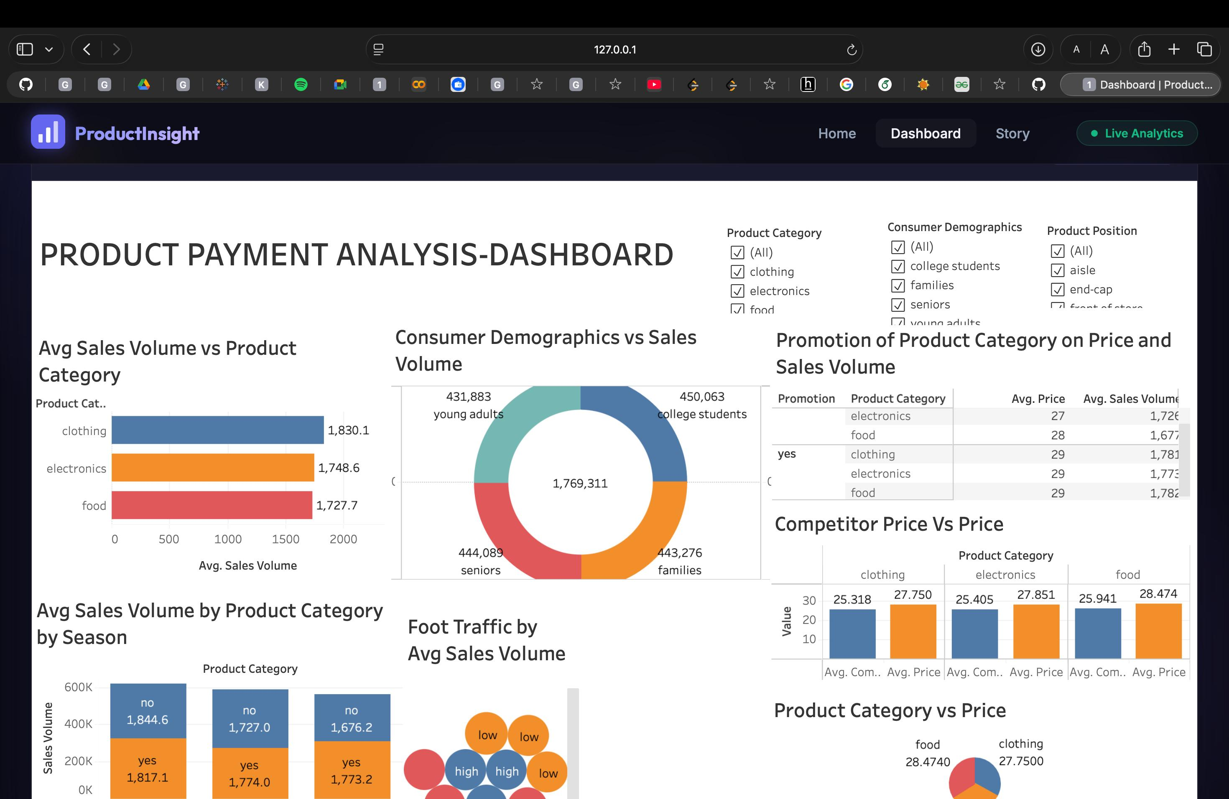
The dashboard enables users to explore data dynamically.

11. Story Creation
A Tableau Story was created to present insights in a structured format.

Story Scene 1
Overview of product sales by category.

Story Scene 2
Impact of product placement on sales volume.

Story Scene 3
Analysis of pricing strategies and promotional impact.
The story helps explain insights step-by-step.

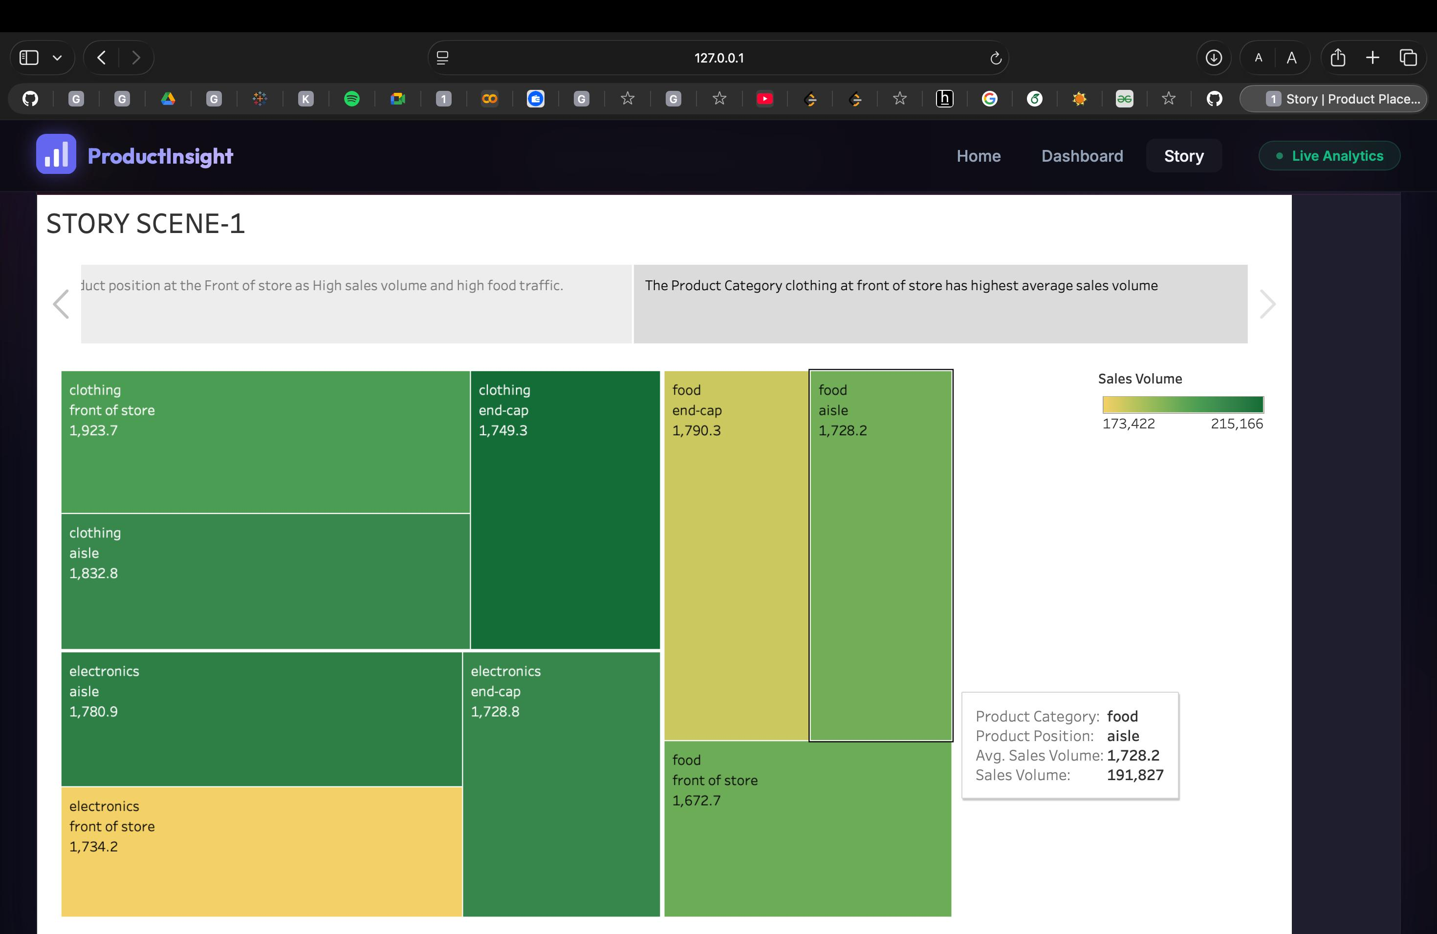

12. Utilization of Filters
Interactive filters were added to enhance the user experience.
Filters include:
- Product Category
- Consumer Demographics
- Product Position
- Seasonal Products
These filters allow users to analyze specific subsets of the dataset.

13. Publishing the Dashboard
After creating the dashboard and story, the workbook was published on Tableau Public.
Steps:
- Open Tableau Desktop
- Click File → Save to Tableau Public
- Login to Tableau Public account
- Publish the workbook
This allows users to access the dashboard online.

14. Web Integration using Flask
To enhance accessibility, the dashboard was integrated into a Flask web application.
Steps performed:
- Copy embed code from Tableau Public
- Create Bootstrap-based web interface
- Insert embed code into HTML template
- Run application using Flask
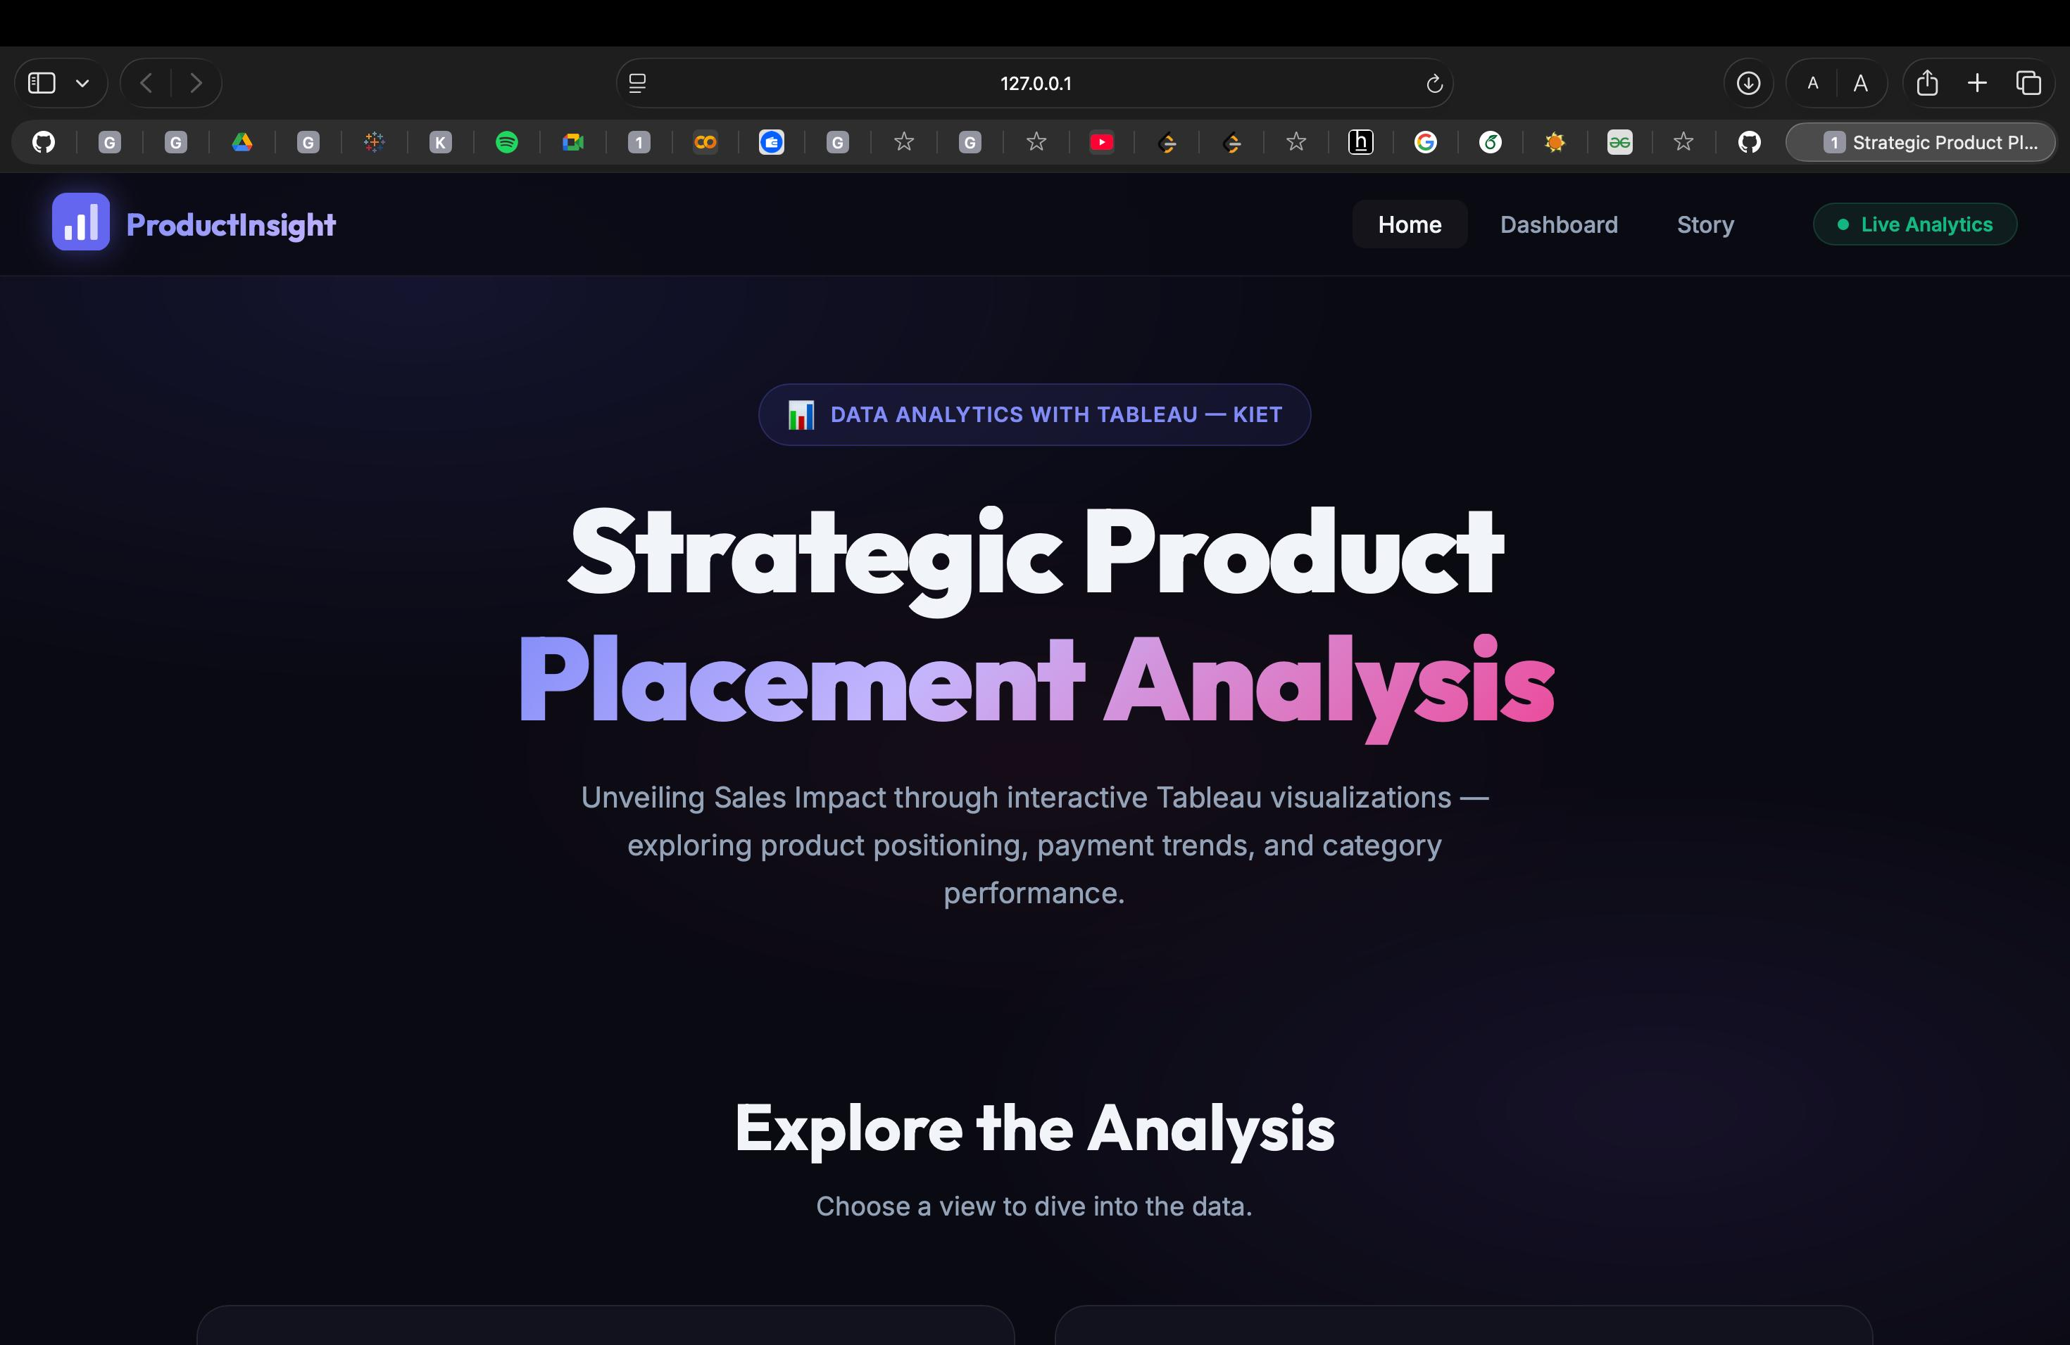
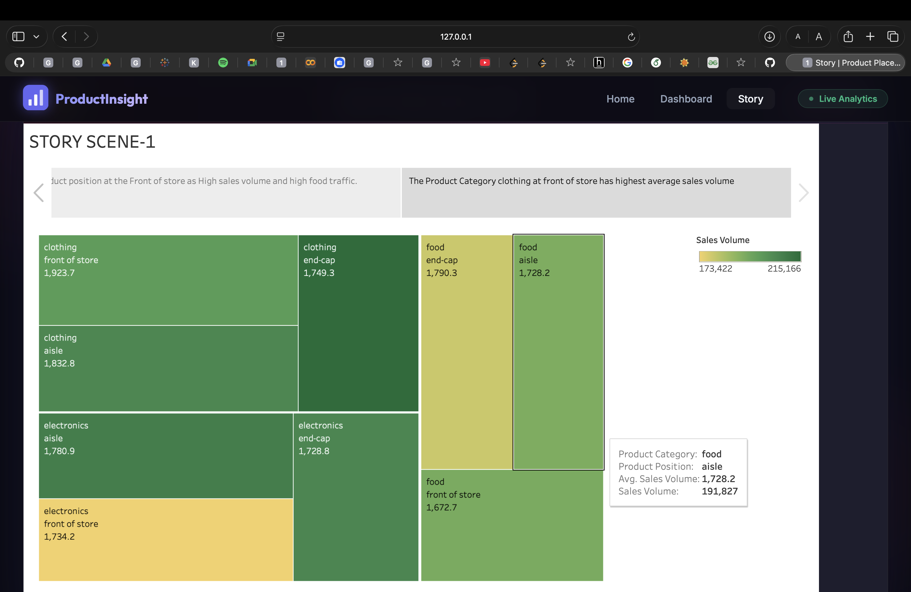
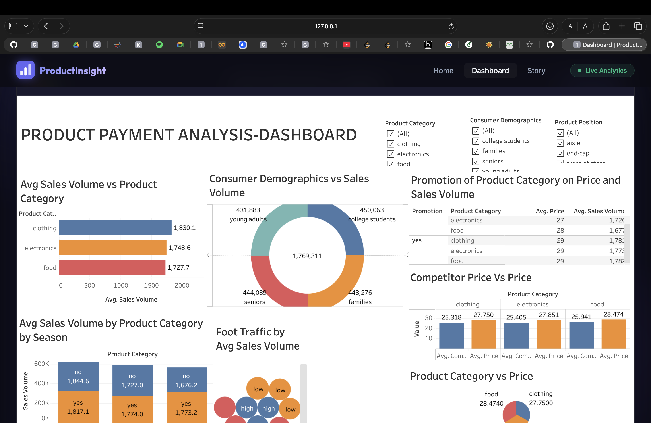
This allows users to interact with the dashboard through a web interface.

15. Key Findings
The analysis revealed several important insights:
- Products placed on endcaps tend to generate higher sales.
- Areas with high foot traffic lead to increased product visibility.
- Promotions significantly increase sales volume.
- Consumer demographics influence purchasing behavior across product categories.

16. Conclusion
This project demonstrates how data analytics and visualization tools can help businesses make better decisions regarding product placement strategies.
Using Tableau dashboards and a Flask-based web interface, the project provides an interactive platform for analyzing retail sales data and identifying key insights.

17. Future Scope
Future improvements may include:
- Adding real-time sales data
- Using machine learning for sales prediction
- Expanding the dataset to include more stores
- Adding advanced analytics features

18. References
Dataset Link :
https://www.kaggle.com/datasets/amitvkulkarni/impact-of-product-positioning-on-sales
Tableu Documentation :
https://www.tableau.com

